Name-Mukesh kumar Yadav Rollno-243528

Ans-1Q1. In your Github account, create a new repository ‘linux_assignments’. Put all the docx/pdf file solutions for your linux assignments in that folder

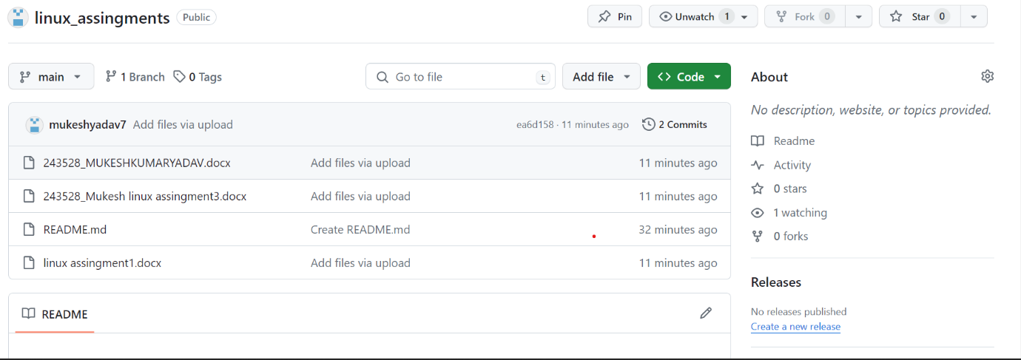

Ans-2Q1. In your Github account, create a new repository ‘linux_assignments’. Put all the docx/pdf file solutions for your linux assignments in that folder

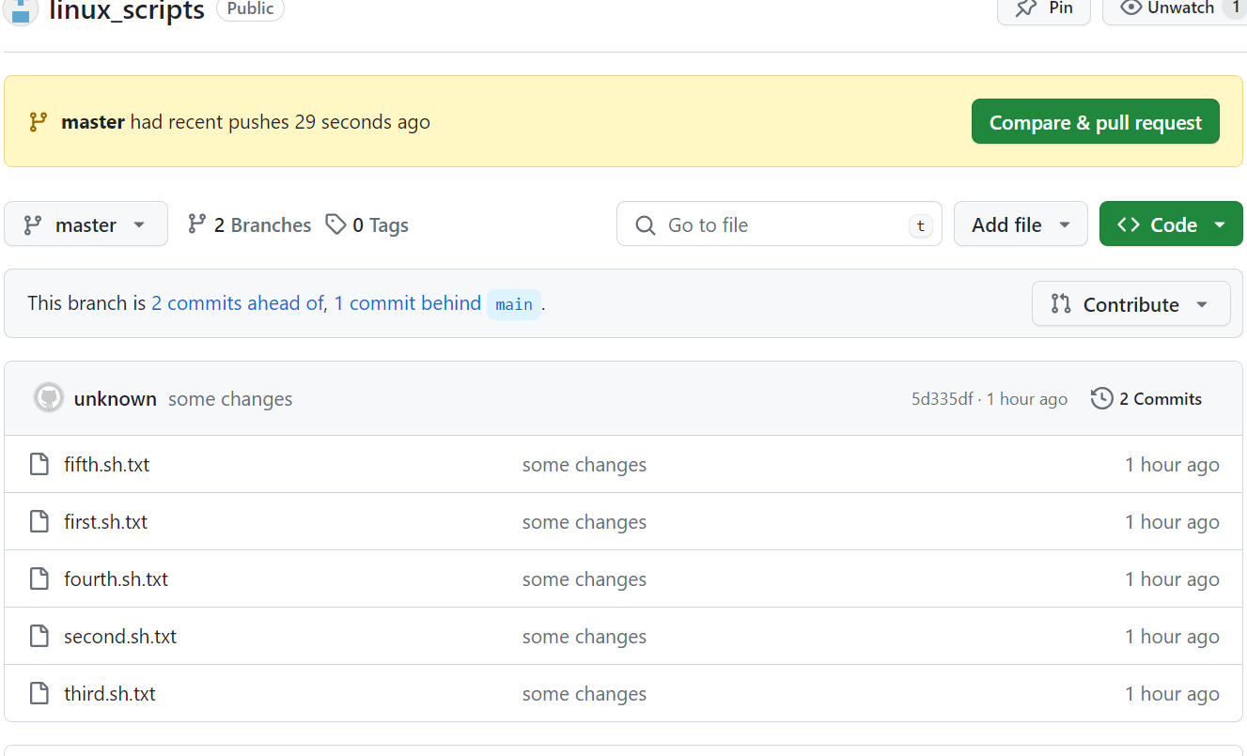

Ans-3 Login to AWS console. Create a new instance of EC2 with Ubuntu. On this instance install git

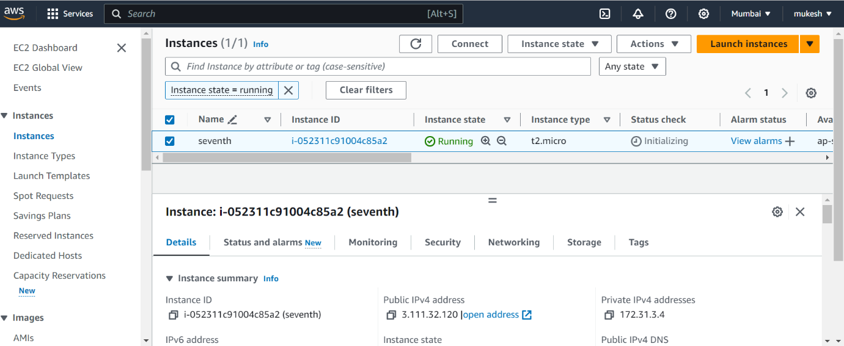

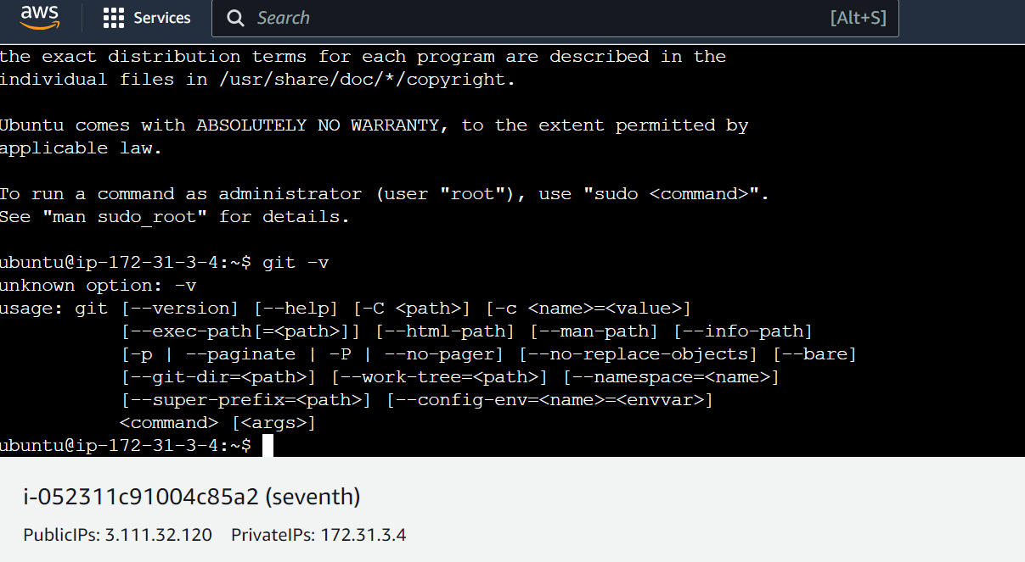

Ans-4After installing git, pull your repository named ‘linux_scripts’. Run scripts inside this repository on ec2 instance. Take screenshots and save them in a docx file.

1. Cloned repository

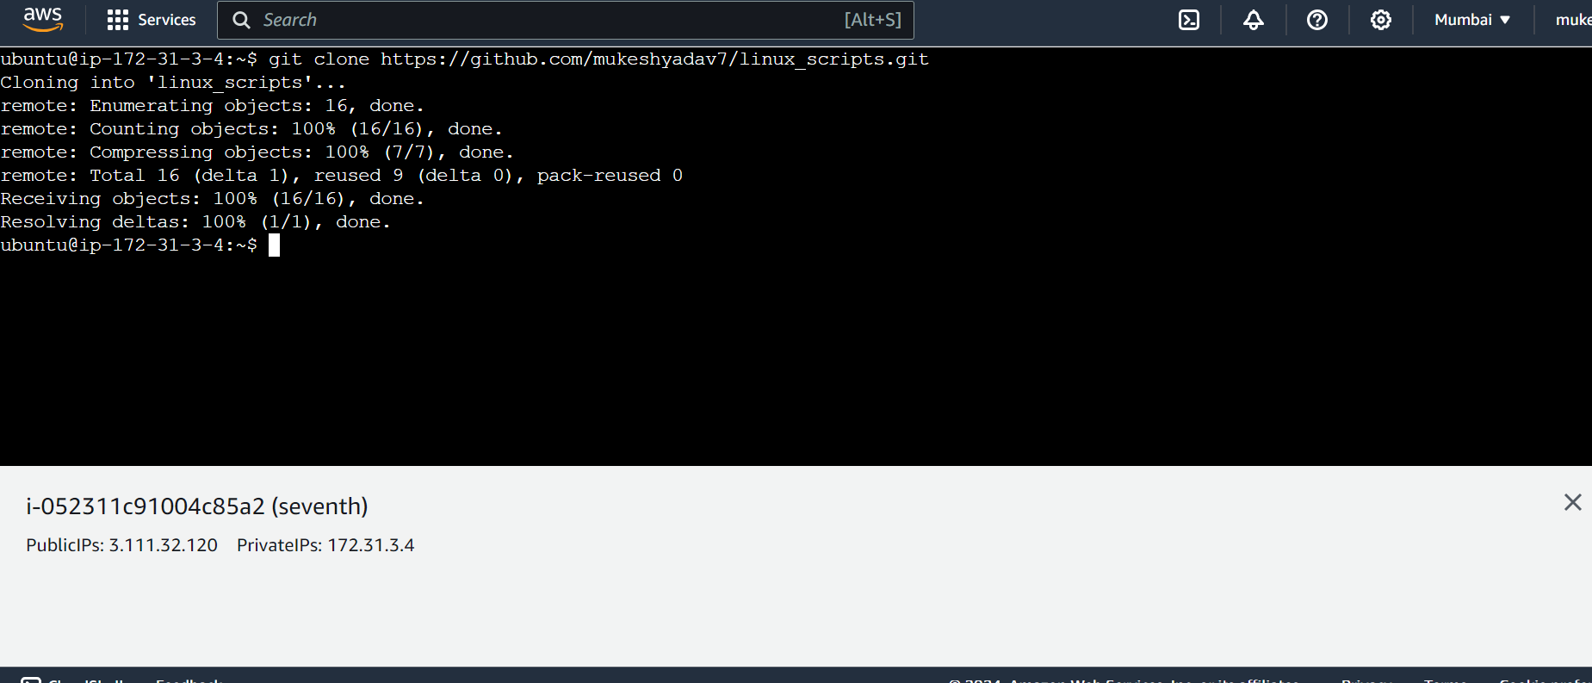

1. Gave execution permission of all files to owner ubuntu

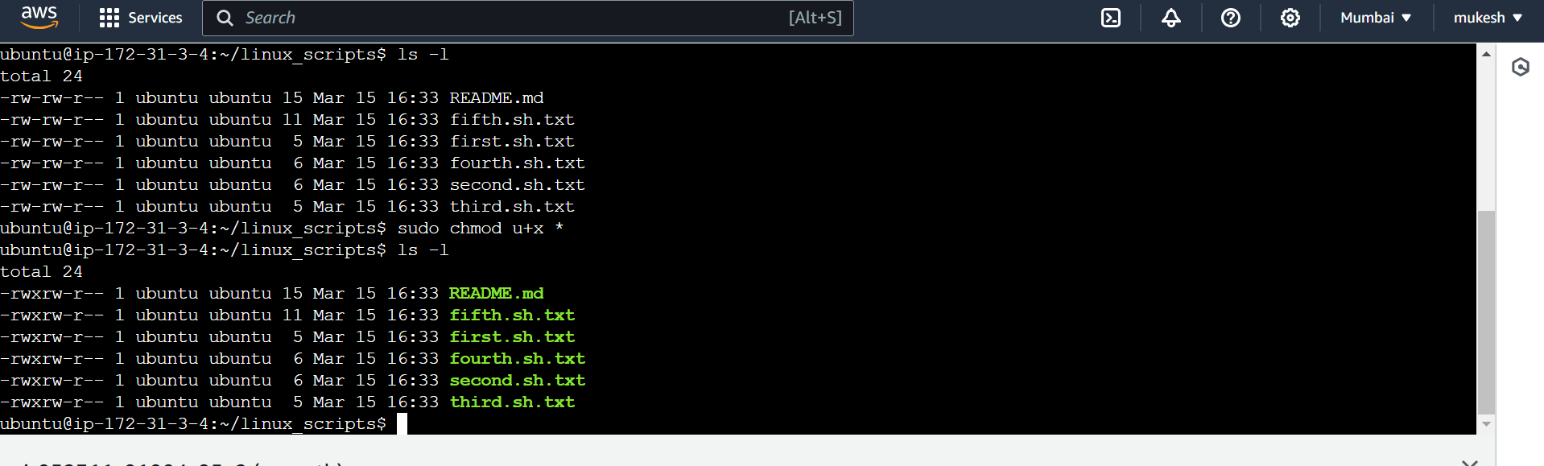

Ans-5. Create a new repository on Github named “linux shell scripting with AWS”. Put the docx file created in Q5 in this repository.

